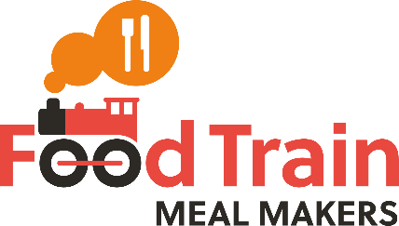
Diner Sign Up Form
Do you have consent from the individual being referred to pass on their personal details ☐
Name: |  |  |  | Date:
Mr/Mrs/Miss/Ms: |  | Gender: |  | D.O.B:
Address:
 |  |  | Postcode:
How many at this address? |  |  | Tel No:
Are there any risk factors that you know of with the Diner or their home? (e.g. virus symptoms, knowledge of previous convictions, dangerous house setting, Diner has violent tendencies, known drug consumption etc)
Pets?
Smoker?

Where did you hear about Meal Makers?
Name of referrer: | Organisation:
Referrers email:
Referrers phone:
Is the Referrer happy to be contacted in the future?

Emergency contact: | Relationship:
Tel No:
Arrange meals with emergency contact?

What does the diner like to eat? (please list as many meals and types of food as possible)

Any dislikes?

Special considerations (e.g. diabetic, coeliac, dairy-free, vegetarian, halal, kosher, allergies)
What (if any) days would be unsuitable for the Diner?

3 facts about Diner e.g. Hobbies, Favourite music/TV/Film/Book, Past Career etc.
1.

2.

3.

If we are to send a volunteer into this person’s home to do a regular meal share is there anything else we should be aware of? (e.g. communication problems, virus symptoms)

Staff Use Only
Have you confirmed these details with a referrer or emergency contact? | ☐
Has the Diner been informed about Food Train Services? | ☐

